Upper Murrumbidgee Larval Cod Dispersal Analysis

Alan Couch

Mon Mar 16 7:37:28 PM 2015

## Loading required package: knitr  
## Loading project configuration  
## Autoloading helper functions  
## Running helper script: helpers.R  
## Autoloading data  
## Loading data set: CladeNamesToMerge  
## Loading data set: DMac14.1567DistMatrix  
## Loading data set: DMac14.1567snps  
## Loading data set: qslLarvaeAgePlus  
## Munging data  
## Running preprocessing script: 01MungeGeneticsData.R

source("http://addictedtor.free.fr/packages/A2R/lastVersion/R/code.R")# load code of A2R function  
library(ggplot2)  
library(ggdendro)  
library(ape)  
library(dendextend)  
library(Hmisc)  
library(ade4)

This document maps out the analysis of the dispersal of Murray cod larvae in the Murriumbidgee river. It includes sampling, larval morphological characteristics, genome profile and a natural biogeochemical markers. The larvae used in the dispersal analysis were collected in 2013 from 6 sites. The data used for ageing were collected over the three years 2011-2013.



## Calculate Some Additional Parameters

This section is to add some calculations to the data set. In particular to add:

Age from Otolith Length: 74.308*[MeanOtolithLength]-4.44361

Hatch DoY : [Day of Year Caught]-[Age From Otolith Length]

Incubation: 20.67-0.667*[WaterTemp(DegC) Mean]

Spawning:[Hatch]-[Incubation]

These additional parameters will be used to estimate distances that the larvae have dispersed based on the number of days available to them since leaving the nest and the day and location of collection. In turn The time available will be used to model the most likely distance travelled by the larvae.

larv$ageOL<-74.308*larv$Mean.Otolith.Length.is.in.Millimetres.for.comparison.with.Adults-4.44361  
larv$hatchdoy<-larv$Day.of.Year-larv$ageOL  
larv$incTime<-20.67-0.667*larv$WaterTemp.DegC..Mean  
larv$spawn<-larv$hatchdoy-larv$incTime  
  
  
#larv[,119:123] #just to see all OK

But before that we need to establish the genetic identies so that we can test the assumption that genetic distance is positively corelated with geographic distance between individuals.

## All Maccullochella Larvae

If we look at all the larvae collected we see four distinct clades.The Trout cod and the hybrids are easily identified and eliminated from the data to ensure we are looking only at the Murray cod larvae.

#Create a distance matrix for all Maccullochella larvae  
MacDm <- dist(allsnps)  
  
#Make a heat map  
dataMatrix <- as.matrix(MacDm)  
heatmap(dataMatrix)

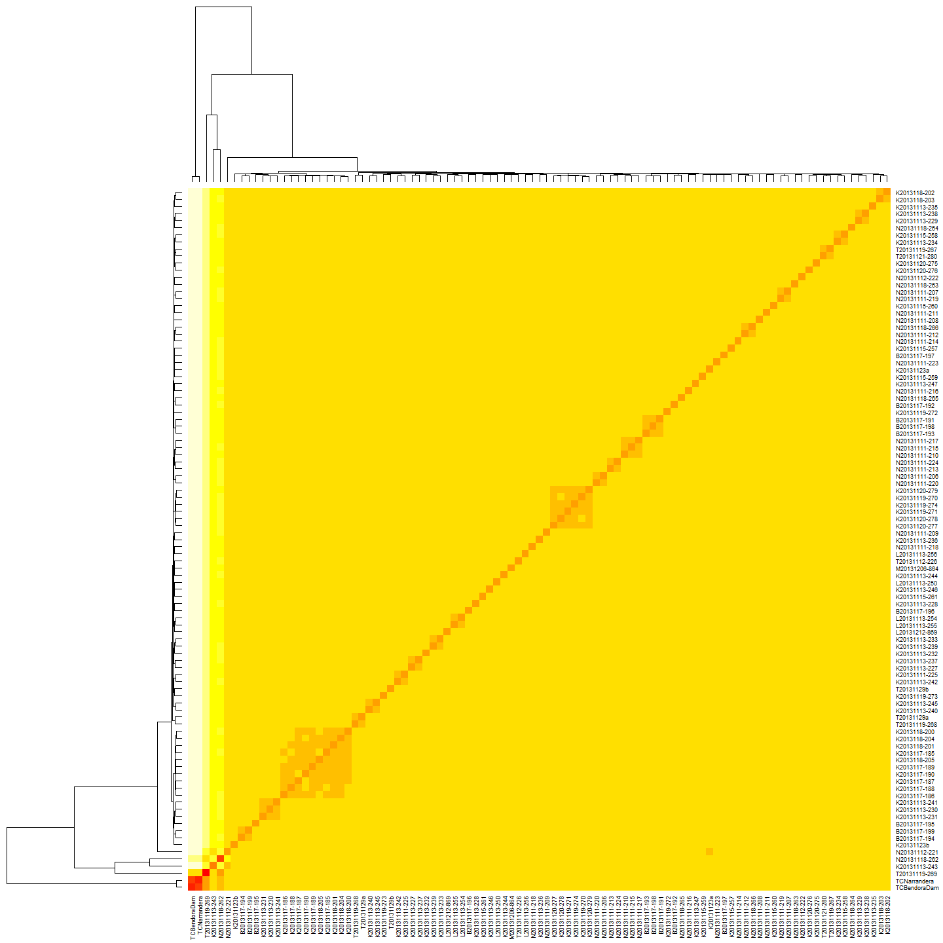

#Do a heirarchical cluster  
MacHC <- hclust(MacDm)  
#Plot the cluster dendrogram  
plot(MacHC, main="All Maccullochella Larvae")

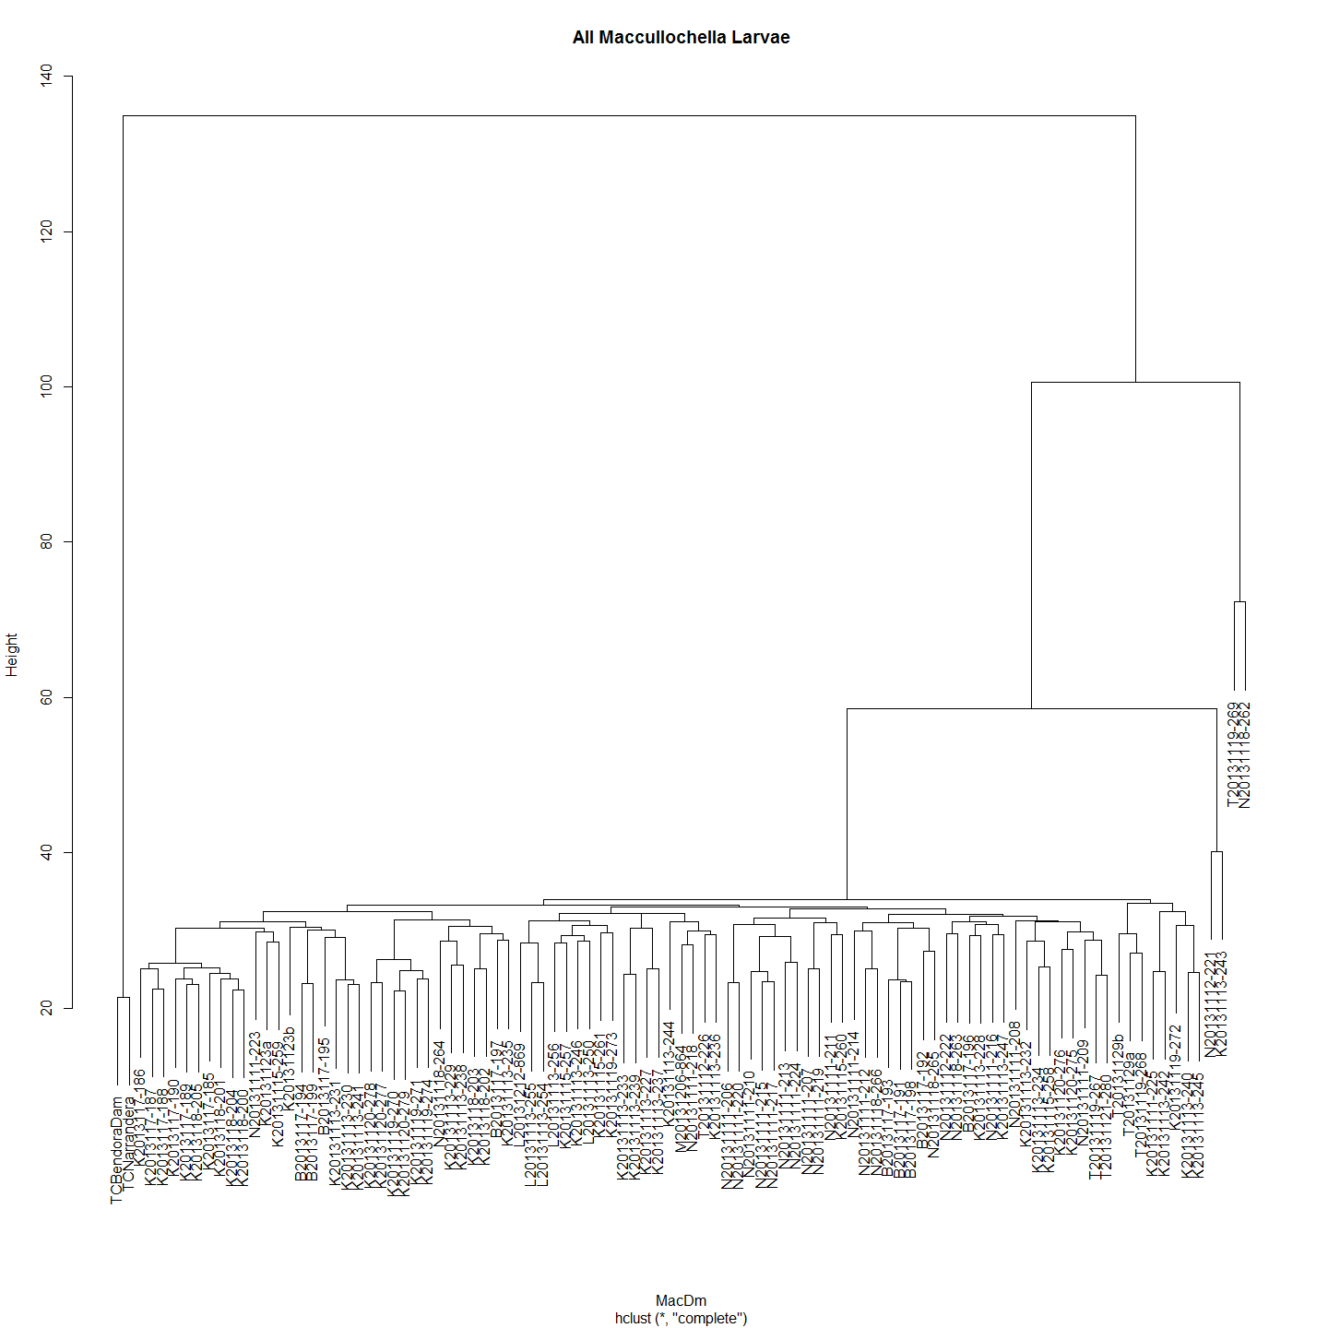

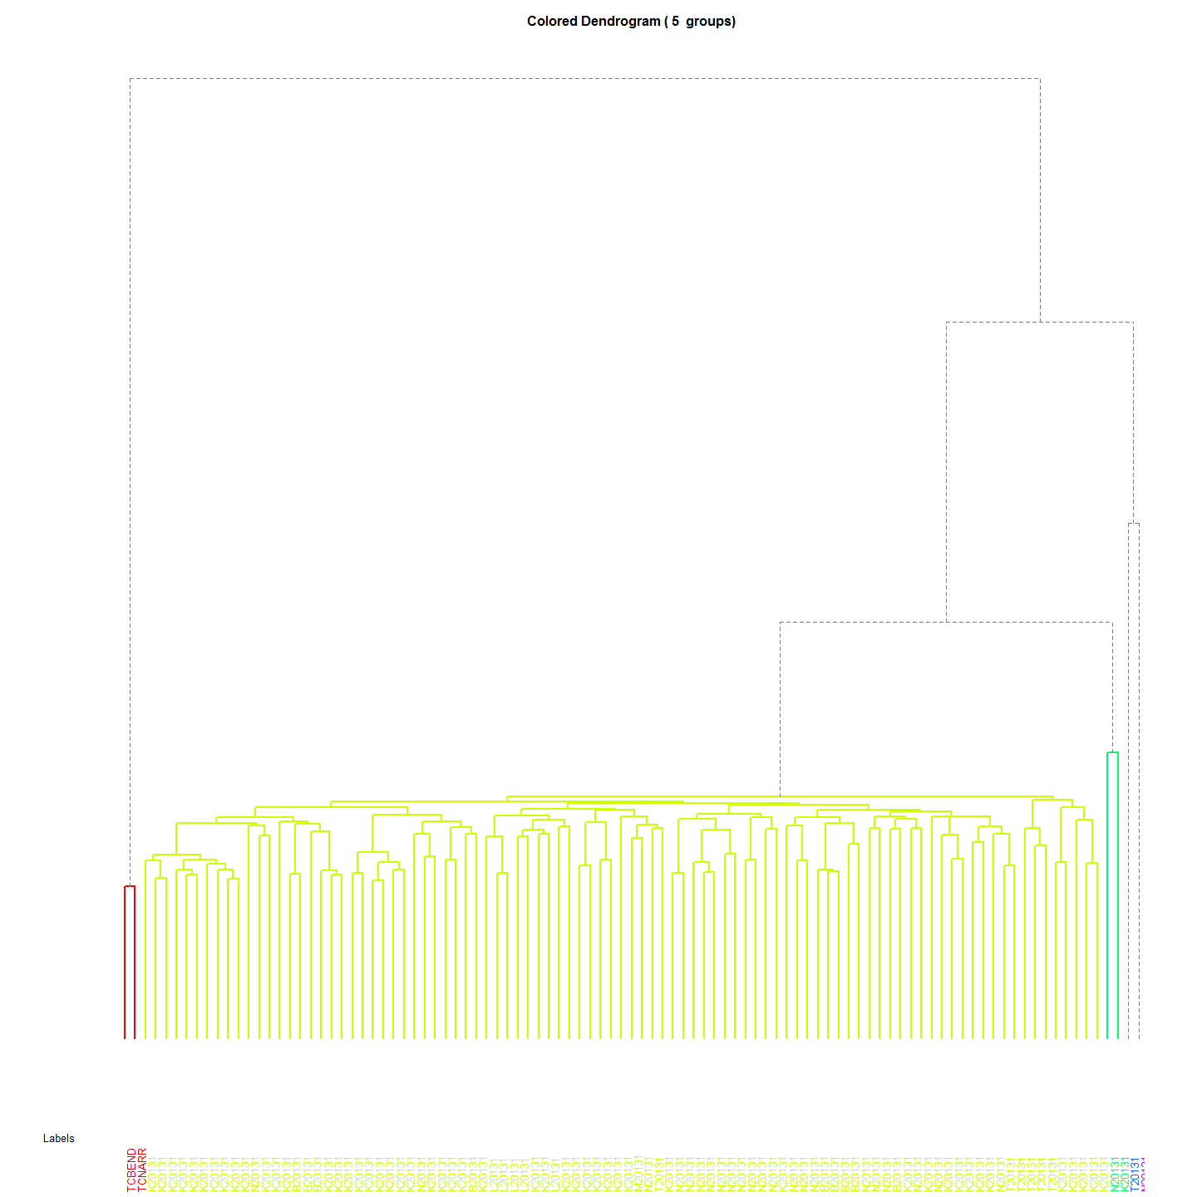 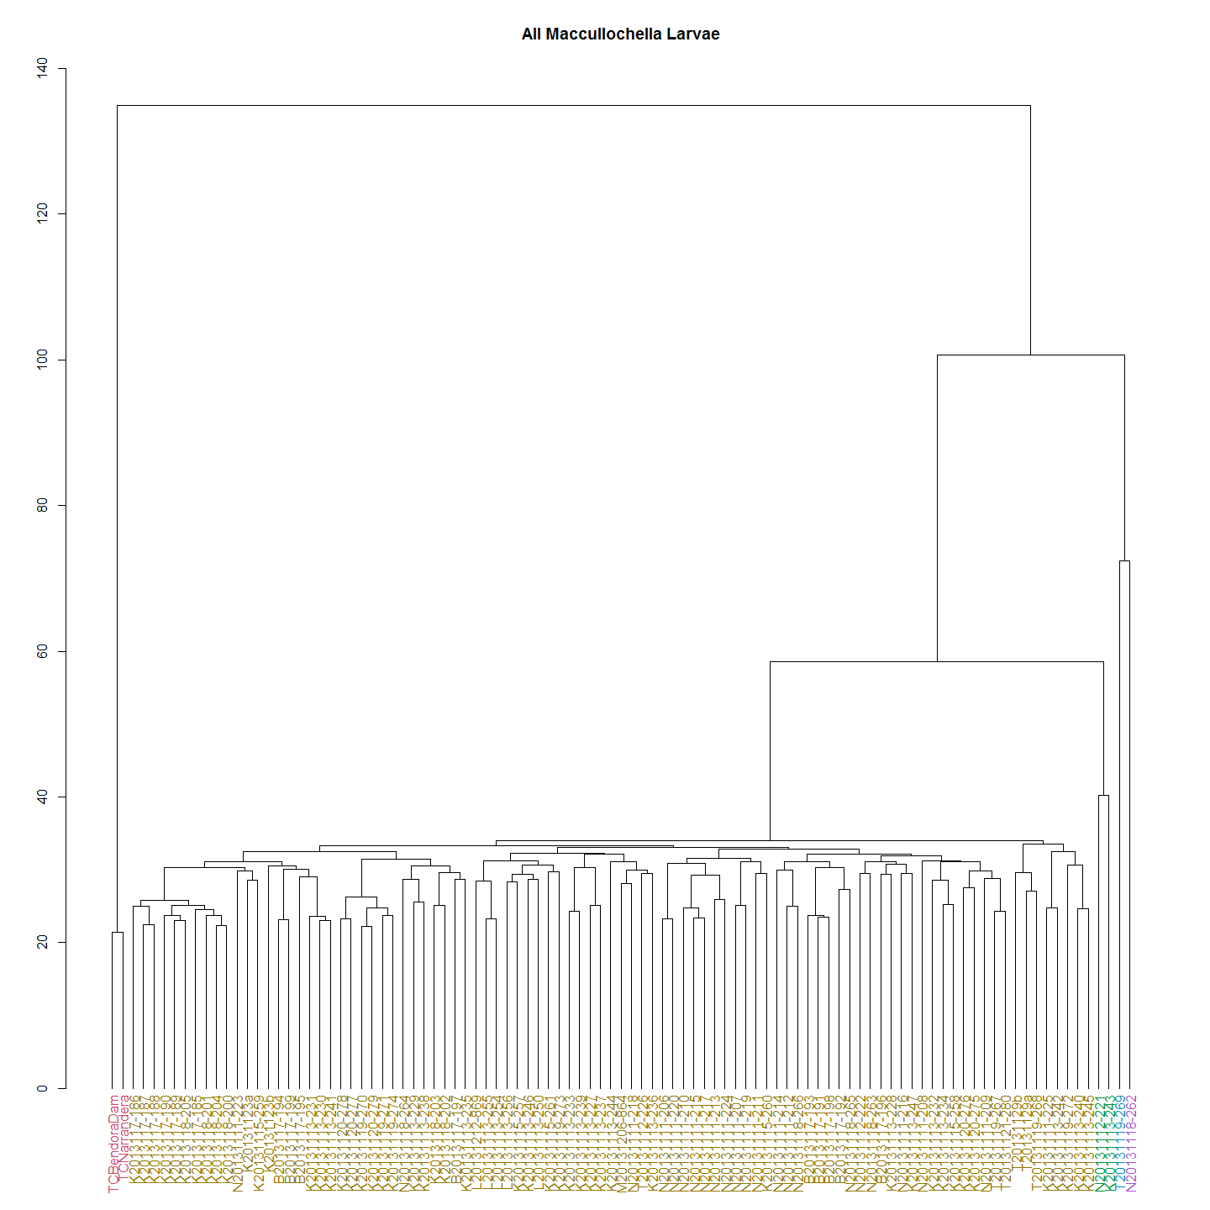

The above dendrograms shows Murray cod and two known Trout cod controls and what appears to be F1 and F2 hybrids. There were only 4 hybrid and 0 pure trout cod larvae deteced in the 92 larvae caught and sequenced.

It will be interesting to mito-sequence the trout cod and determine the species of the male and female parent. I expect that the female is the Trout cod given the scarcity of trout cod compared with Murray cod and the mate pressure that must exist.

So we now remove the non- Murray cod to identify Murray cod haplogroups and conduct the remainder of the analysis on the Upper Murrumbidgee Murray cod larvae only.

## Murray Cod Larvae

#Create a Murray Cod distance matrix  
MCdm <- dist(MCsnps)  
#Heat map  
dataMatrix <- as.matrix(MCdm)  
heatmap(dataMatrix)

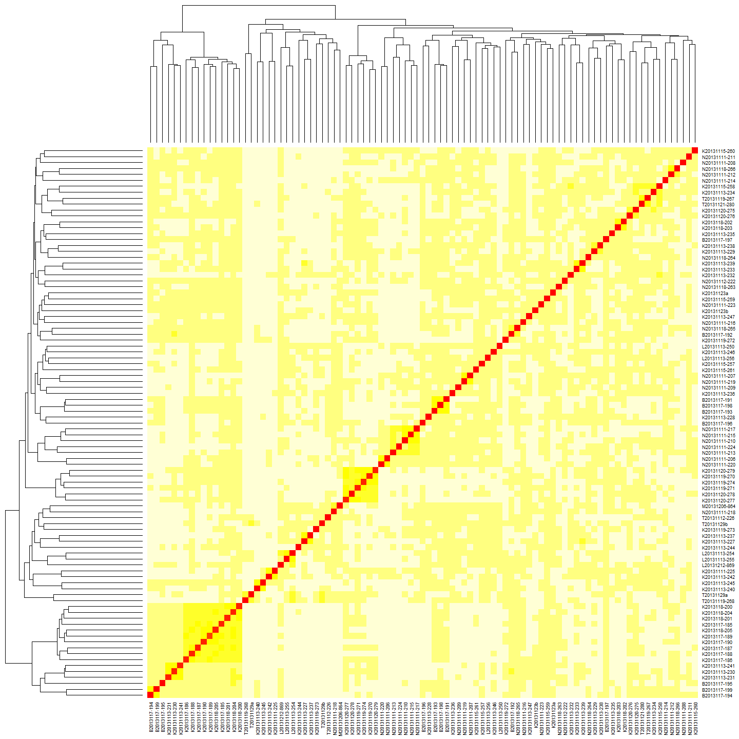

#cluster  
MChc <- hclust(MCdm)  
#Plot it  
plot(MChc,main="Maccullochella peelii Larvae")

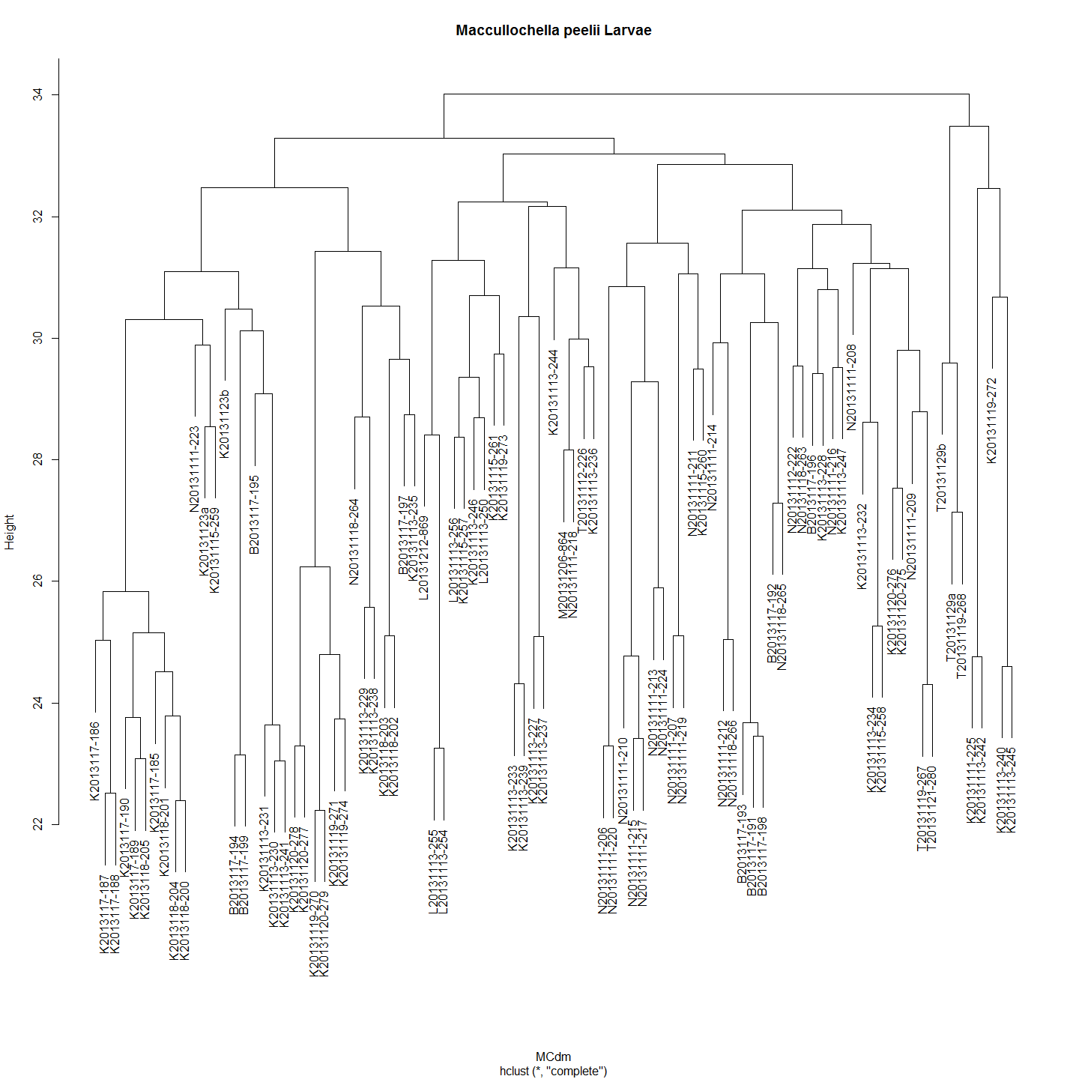

The distance matrix suggest a very low genetic diversity in the population of Murray cod sampled. Given this, how to determine if the closely related larvae are siblings?

In most cases very closely related larvae have been collected at the same spot over the same couple of days. But in some cases very closely related pairs of larvae have turned up at different sites. Sometimes over time frames that seem unlikely or suggest the larvae have travelled upstream. However, must remember that it is siblings - not the same fish - that is caught so this might just represent the 'smear' of larvae along the river after dispersing from the nest.

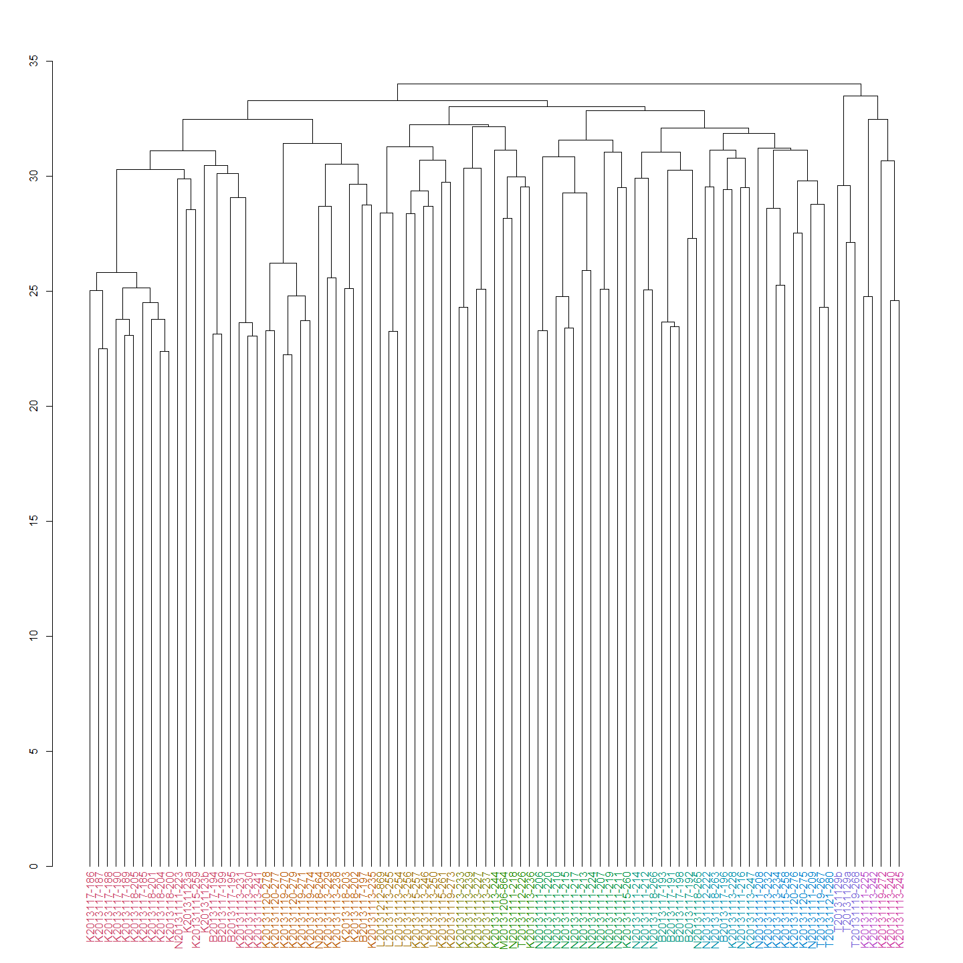

# basic option  
ggdendrogram(MChc, rotate = TRUE, size = 4, theme_dendro = FALSE)

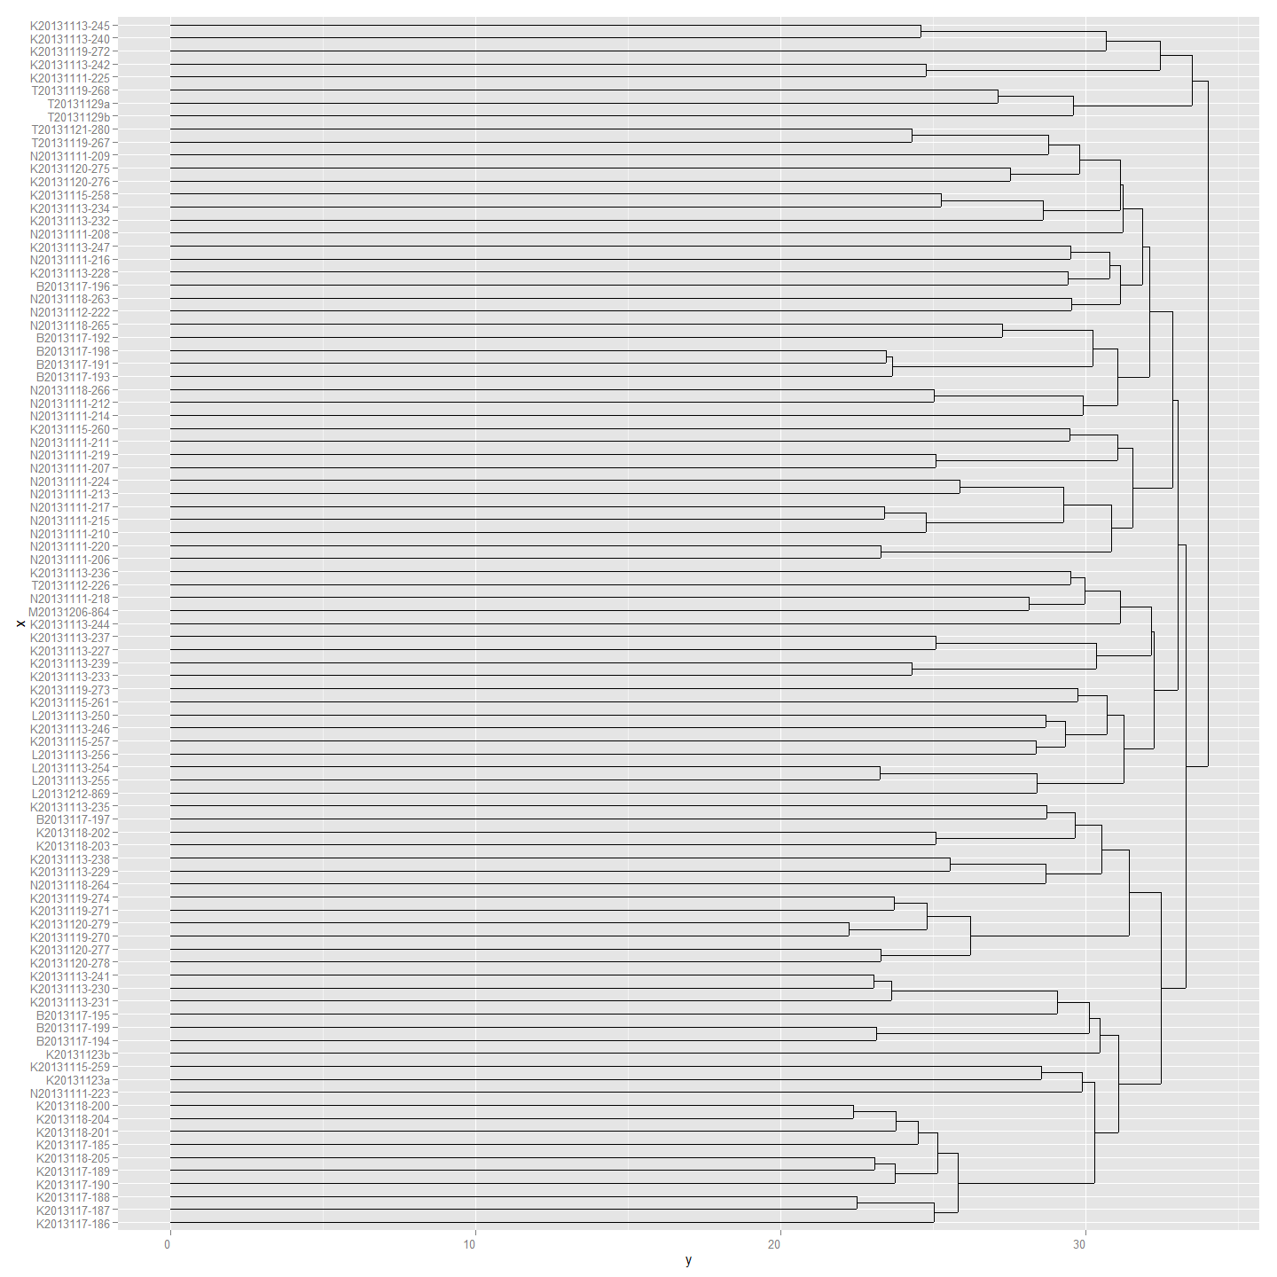 The Murray cod can be resolved into 12 clades. Can I call these Haplogroups? Is 12 the right sort of cutoff? Should there be more?

#dend1 <- color_branches(MChc, k = 12)  
# Get the package:  
#cutree(dend1,h=70) # it now works on a dendrogram. Use h or k  
# It is like using:  
#dendextend:::cutree.dendrogram(dend1,h=70)  
  
cladeNo<-cutree(dend1,k=12)  
cladeNo<-as.data.frame(cladeNo)  
cladeNo #The clades are numbered by default.

## cladeNo  
## N20131112-222 1  
## L20131212-869 2  
## K20131123a 3  
## K20131123b 3  
## M20131206-864 4  
## T20131129a 5  
## T20131129b 5  
## K2013117-185 3  
## B2013117-194 3  
## B2013117-195 3  
## B2013117-196 1  
## K2013117-186 3  
## K2013117-187 3  
## K2013117-188 3  
## K2013117-189 3  
## K2013117-190 3  
## B2013117-191 6  
## B2013117-192 6  
## B2013117-193 6  
## N20131111-208 7  
## B2013117-199 3  
## B2013117-198 6  
## B2013117-197 8  
## N20131111-207 9  
## N20131111-206 9  
## K2013118-205 3  
## K2013118-204 3  
## K2013118-203 8  
## K2013118-202 8  
## K2013118-201 3  
## K2013118-200 3  
## N20131111-209 7  
## N20131111-218 4  
## N20131111-219 9  
## N20131111-220 9  
## N20131111-210 9  
## N20131111-211 9  
## N20131111-212 6  
## N20131111-213 9  
## N20131111-214 6  
## N20131111-215 9  
## N20131111-216 1  
## N20131111-217 9  
## K20131113-232 7  
## N20131111-223 3  
## T20131119-268 5  
## K20131113-231 3  
## K20131113-230 3  
## K20131113-229 8  
## K20131113-228 1  
## K20131113-227 10  
## T20131112-226 4  
## K20131111-225 11  
## N20131111-224 9  
## K20131113-233 10  
## K20131113-242 11  
## K20131113-244 4  
## K20131113-234 7  
## K20131113-235 8  
## K20131113-236 4  
## K20131113-237 10  
## K20131113-238 8  
## K20131113-239 10  
## K20131113-240 12  
## K20131113-241 3  
## L20131113-256 2  
## K20131113-247 1  
## K20131113-246 2  
## K20131113-245 12  
## L20131113-255 2  
## L20131113-254 2  
## L20131113-250 2  
## K20131115-257 2  
## N20131118-266 6  
## T20131119-267 7  
## K20131115-258 7  
## K20131115-259 3  
## K20131115-260 9  
## K20131115-261 2  
## N20131118-263 1  
## N20131118-264 8  
## N20131118-265 6  
## T20131121-280 7  
## K20131119-271 8  
## K20131119-270 8  
## K20131120-279 8  
## K20131120-278 8  
## K20131120-277 8  
## K20131120-276 7  
## K20131120-275 7  
## K20131119-274 8  
## K20131119-273 2  
## K20131119-272 12

## Trout Cod Larvae

#and a Trout Cod   
TCdm <- dist(TCsnps)  
#Heat map  
dataMatrix <- as.matrix(TCdm)  
heatmap(dataMatrix)

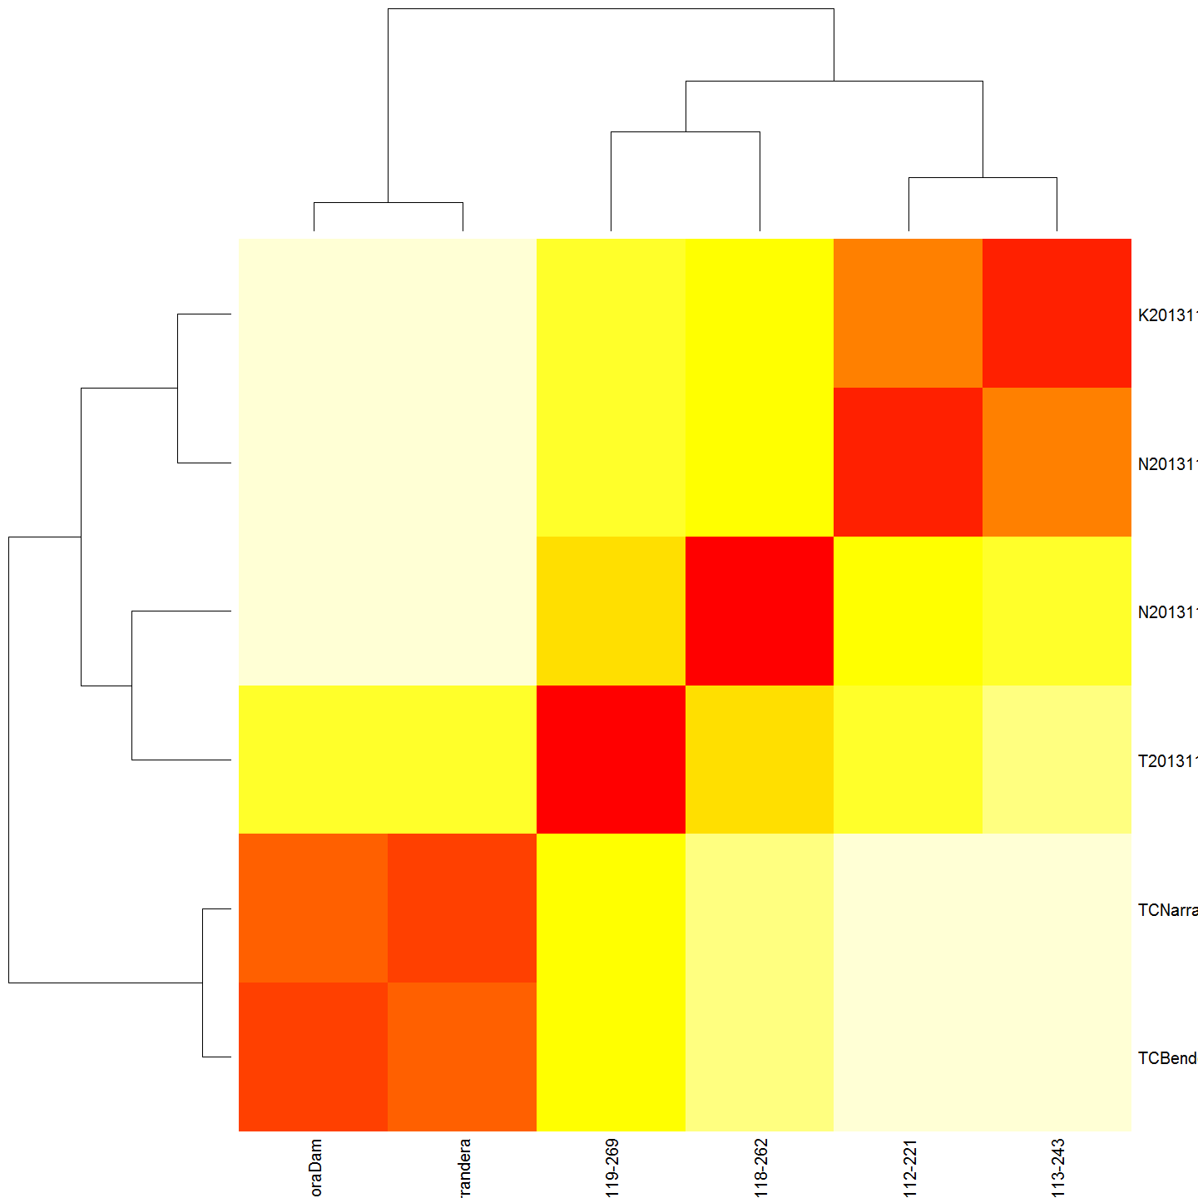

#cluster  
TChc <- hclust(TCdm)  
#Plot it  
#plot(TChc, main="Maccullochella macquariensis larvae")  
A2Rplot(TChc, k =3, boxes = FALSE, col.up = "gray50",main = "Maccullochella macquariensis larvae")

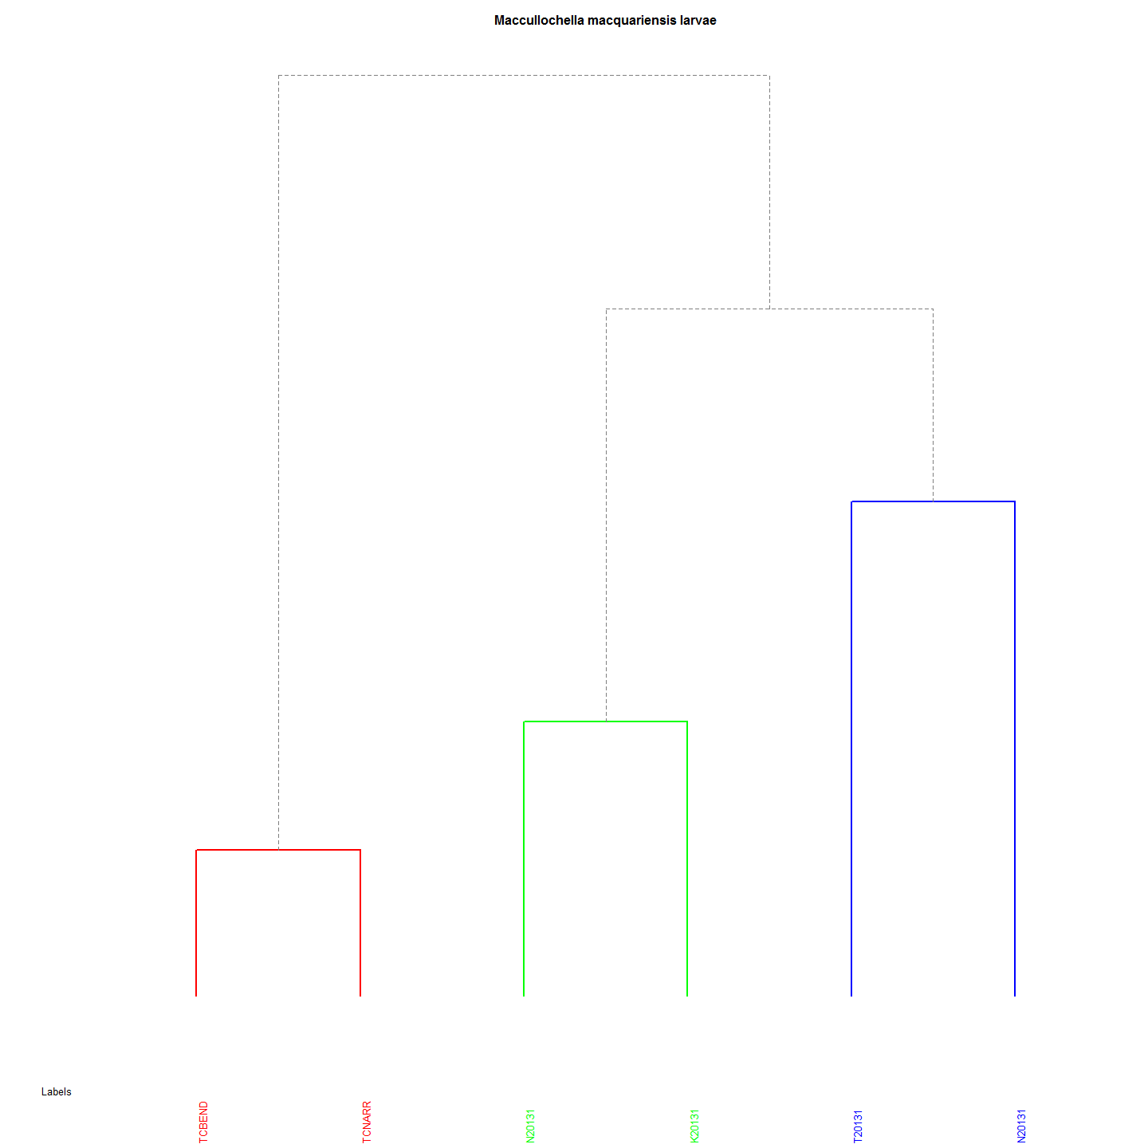

# Upper Murrumbidgee Larval Cod Genetic and Geographic Distances

# read chunk (does not run code)

# run the IM chunk (all) IteratedMantel

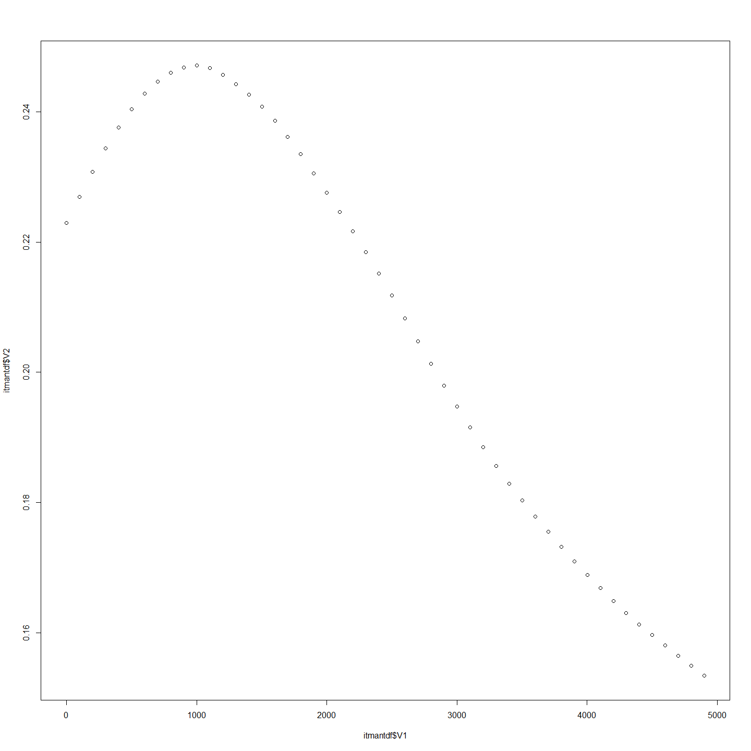 This document maps out the physical distances with genetic distance of larvae from the Murrumbidgee collected in 2013 from 6 sites. To create distance matrix to tes

# To create a distance  
larv$nestdist<-larv$Distance.to.Angle.Crossing..m.-(BestNestEst*(larv$Day.of.Year-(larv$hatchdoy+7)))  
  
#remove larvae that do not have genetic analysis done.  
#Creat a MCsnps set with row names as a column.  
MCchecklist<-row.names(MCsnps)  
MCchecklist<-as.data.frame(MCchecklist)# 93 records  
  
#remove a few more anomolies  
MCchecklist1 <- as.data.frame(MCchecklist[-c(1:7), ])  
# Keep every record in larv that is also in MCchecklist (i.e., the intersection).  
  
larv_intersection <- larv[larv$Label %in% MCchecklist$MCchecklist,]  
#Thanks: https://heuristically.wordpress.com/2009/10/08/delete-rows-from-r-data-frame/  
  
larv<-larv_intersection  
larv_intersection<-NULL  
  
###########  
# Re creat GenDist from code in dendrograms code file  
# Create a Murray Cod distance matrix  
MCdm<-MCsnps[-c(1:7),]  
MCdm <- dist(MCdm)  
MCdm<-as.matrix(MCdm)  
MCdm<-as.data.frame(MCdm)  
#This is to be used for plotting  
###########  
  
geodist<-data.frame(larv$Label,larv$nestdist)  
row.names(geodist)<-geodist[,1]  
geodist$larv.Label<-NULL  
geodist<-na.omit(geodist)  
geodist1000<-geodist #save this estimate for haplogroups distance plot (after the Iterated Mantel has changed it)  
  
GeoDistMat<-dist(geodist)  
GeoDistMathm <- as.matrix(GeoDistMat)  
heatmap(GeoDistMathm)

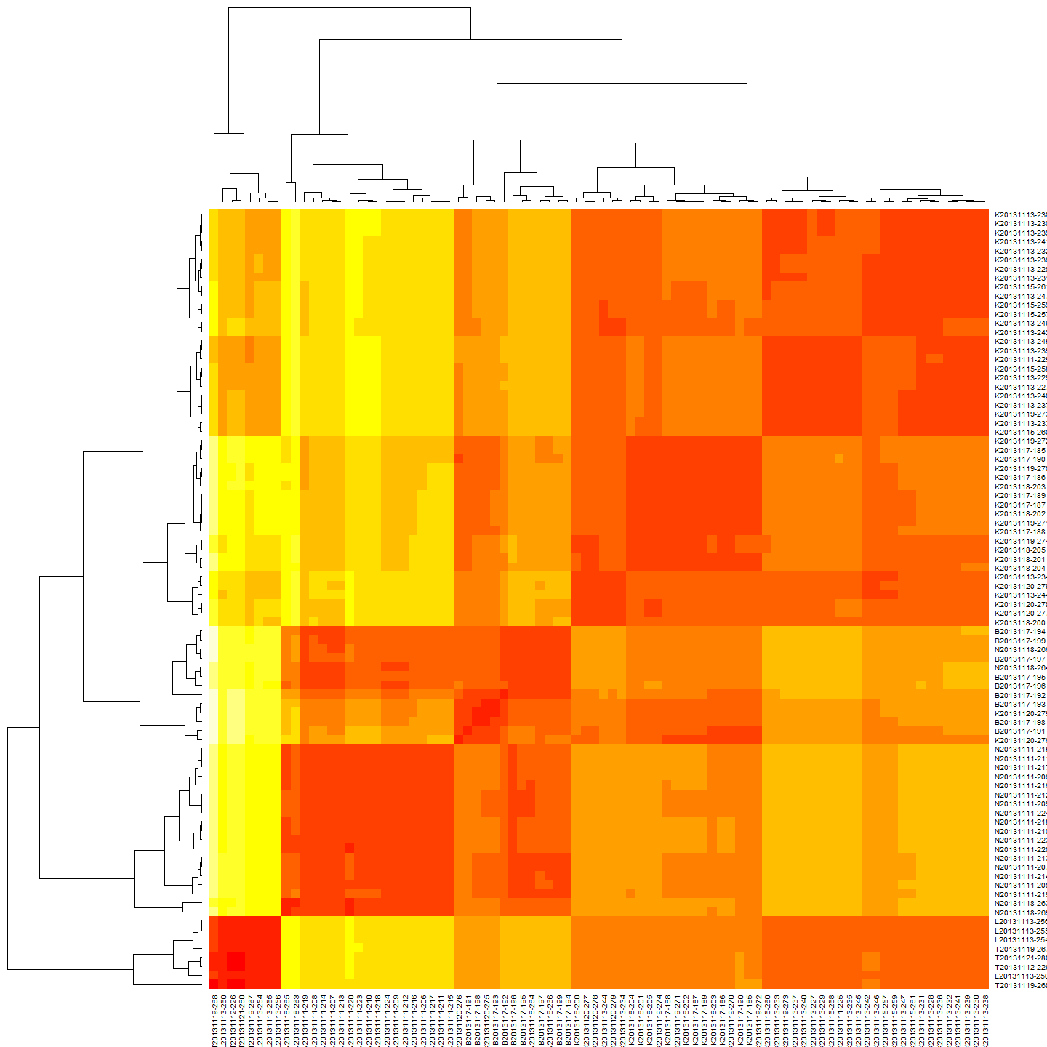

geoclust<-hclust(GeoDistMat)  
plot(geoclust)

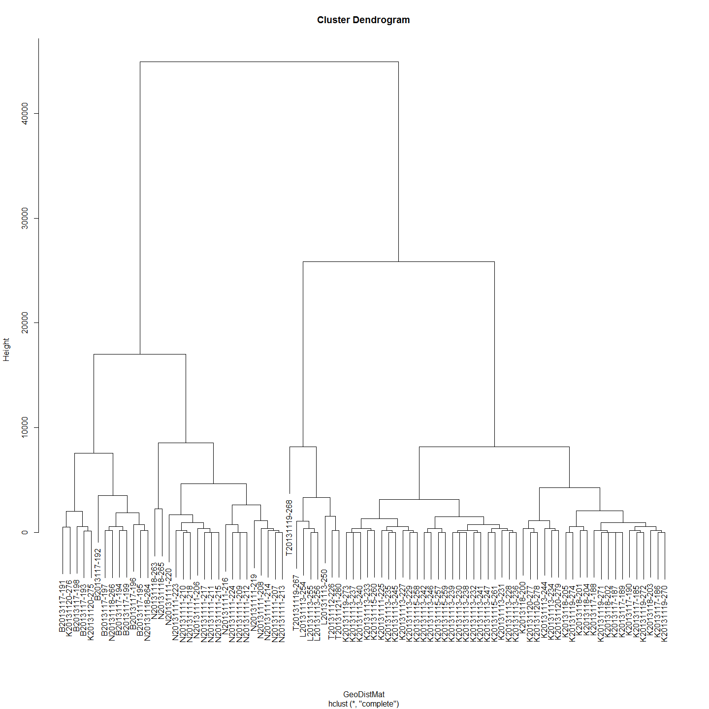

#make sure both matrices are in correct order - rows and cols  
#First sort MCdm  
  
MCdm<-as.data.frame(MCdm)  
MCdm$sort<-row.names(MCdm)  
MCdm <- MCdm[order(MCdm$sort),]#sort row order  
MCdm$sort<-NULL  
MCdm<-MCdm[,order(names(MCdm))]#sort column order  
MCdm<-as.matrix(MCdm)  
  
#Second sort GeoDist  
GeoDistMathm<-as.data.frame(GeoDistMathm)  
GeoDistMathm$sort<-row.names(GeoDistMathm)  
GeoDistMathm <- GeoDistMathm[order(GeoDistMathm$sort),]#sort row order  
GeoDistMathm$sort<-NULL  
GeoDistMathm<-GeoDistMathm[,order(names(GeoDistMathm))]#sort column order  
GeoDistMathm<-as.matrix(GeoDistMathm)  
  
larv1<-larv#save this estimate for haplogroups distance plot (after the Iterated Mantel has changed it)

Now that these various matrices, class 'dist' objects are created we can proceed for plot.

## Plot and Correlate genetic and geographic distance matrices

#plot(GeoDistMathm[lower.tri(GeoDistMathm)],MCdm[lower.tri(MCdm)])  
plot(GeoDistMathm[lower.tri(GeoDistMathm)],MCdm[lower.tri(MCdm)])

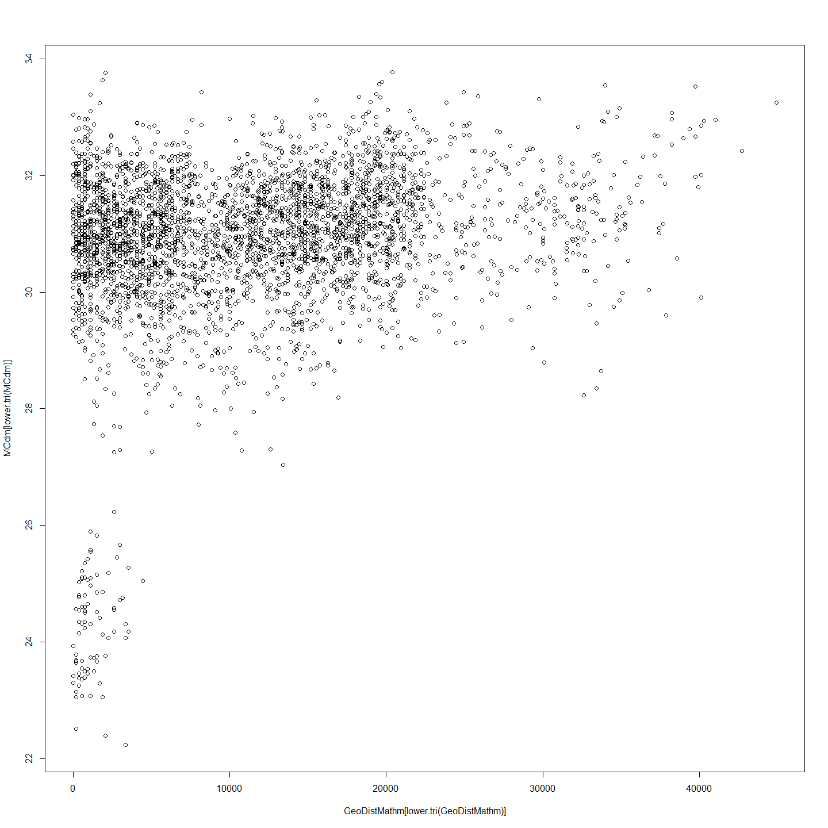

# Correlations with significance levels  
rcorr(GeoDistMathm[lower.tri(GeoDistMathm)],MCdm[lower.tri(MCdm)])#(x, type="pearson") # type can be pearson or spearman

## x y  
## x 1.00 0.25  
## y 0.25 1.00  
##   
## n= 3655   
##   
##   
## P  
## x y   
## x 0  
## y 0

So there is some small but significant correlation between genetic distance and geographic distance in the Murray cod sampled.

## Linear Regression Model

reg=lm(MCdm[lower.tri(MCdm)]~GeoDistMathm[lower.tri(GeoDistMathm)])  
summary(reg)

##   
## Call:  
## lm(formula = MCdm[lower.tri(MCdm)] ~ GeoDistMathm[lower.tri(GeoDistMathm)])  
##   
## Residuals:  
## Min 1Q Median 3Q Max   
## -8.324 -0.472 0.184 0.757 3.256   
##   
## Coefficients:  
## Estimate Std. Error t value Pr(>|t|)   
## (Intercept) 3.04e+01 3.64e-02 834.9 <2e-16 ***  
## GeoDistMathm[lower.tri(GeoDistMathm)] 3.95e-05 2.56e-06 15.4 <2e-16 ***  
## ---  
## Signif. codes: 0 '***' 0.001 '**' 0.01 '*' 0.05 '.' 0.1 ' ' 1  
##   
## Residual standard error: 1.34 on 3653 degrees of freedom  
## Multiple R-squared: 0.0611, Adjusted R-squared: 0.0608   
## F-statistic: 238 on 1 and 3653 DF, p-value: <2e-16

plot(GeoDistMathm[lower.tri(GeoDistMathm)],MCdm[lower.tri(MCdm)])  
abline(reg)

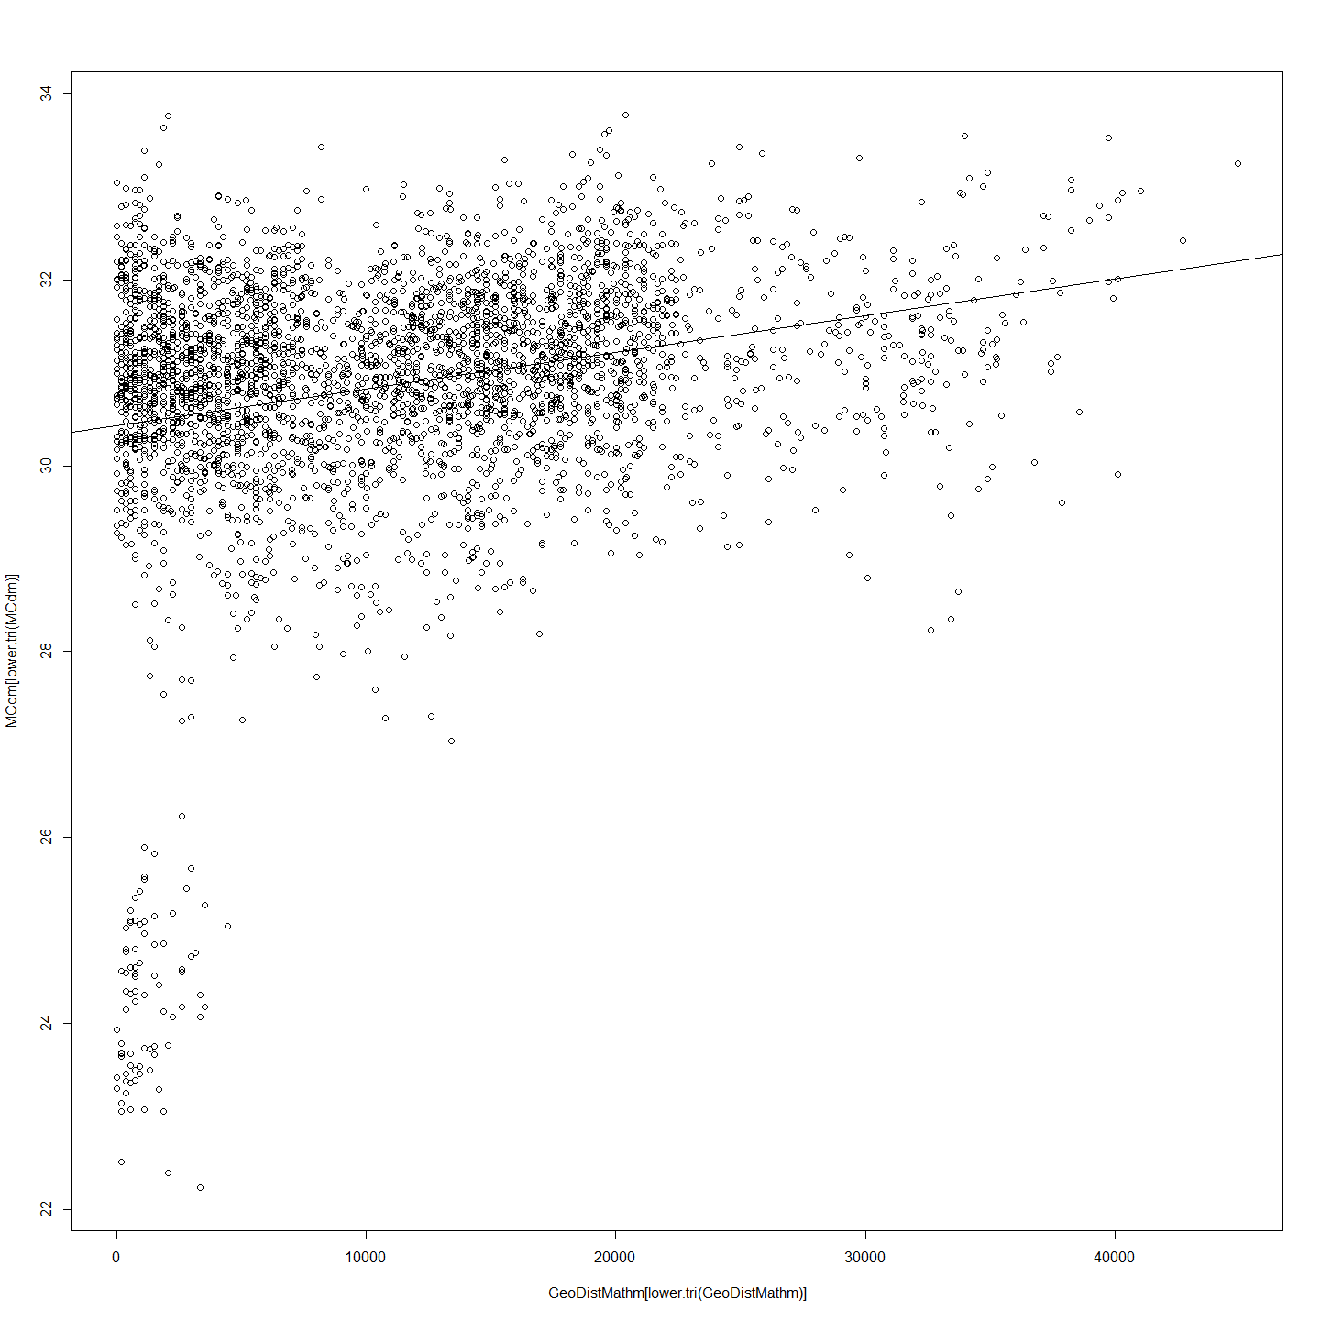

## Mantel Test

mant<-mantel.rtest(as.dist(GeoDistMathm), as.dist(MCdm), nrepet = 9999)  
mant

## Monte-Carlo test  
## Observation: 0.2471   
## Call: mantel.rtest(m1 = as.dist(GeoDistMathm), m2 = as.dist(MCdm),   
## nrepet = 9999)  
## Based on 9999 replicates  
## Simulated p-value: 1e-04

#Check all is in order  
as.matrix(GeoDistMathm)[1:5, 1:5]

## B2013117-191 B2013117-192 B2013117-193 B2013117-194 B2013117-195  
## B2013117-191 0 3530 1486 5758.9 6316.2  
## B2013117-192 3530 0 2043 2229.2 2786.5  
## B2013117-193 1486 2043 0 4272.7 4830.0  
## B2013117-194 5759 2229 4273 0.0 557.3  
## B2013117-195 6316 2787 4830 557.3 0.0

as.matrix(MCdm)[1:5, 1:5]

## B2013117-191 B2013117-192 B2013117-193 B2013117-194 B2013117-195  
## B2013117-191 0.00 30.08 23.66 30.13 30.33  
## B2013117-192 30.08 0.00 30.05 28.74 30.06  
## B2013117-193 23.66 30.05 0.00 30.12 29.26  
## B2013117-194 30.13 28.74 30.12 0.00 29.87  
## B2013117-195 30.33 30.06 29.26 29.87 0.00

Based on these results, we can reject the null hypothesis that these two matrices, spatial distance and genetic distance, are unrelated with alpha = 10-4. The observed correlation, 0.2471, suggests that the matrix entries are positively associated. So smaller differences in genotype are generally seen among pairs of larvae that are from nests estimated to be geographicallyclose to each other, rather than nests which are estimated to be further away from each other. Note that since this test is based on random permutations, the same code will always arrive at the same observed correlation but rarely the same p-value.

The question needs to be asked, and answered, as to how the 1000m distance used in the nest distance estimation equation was derived. This was estimated by iterating the Mantel test for each distance matrix calculated after calculating that matrix using a 'larval dispersal' distance from 1 m to 5000 metres.The highest corellation suggests that it is the distance that best represents the average distance that larvae disperse. The curve produced from the estimations is as follows.

## Look at Haplogroups Over the River Reach

larv1<-merge(larv,cladeNo, by="row.names")  
rownames(CladeNamesToMerge) <- CladeNamesToMerge[,1]  
CladeNamesToMerge$Label<-rownames(CladeNamesToMerge)  
larv2<-merge(larv1,CladeNamesToMerge, by="Label")  
plot(larv2$nestdist,larv2$clade, xlab="Nest Distance (m)", ylab = "Clade")

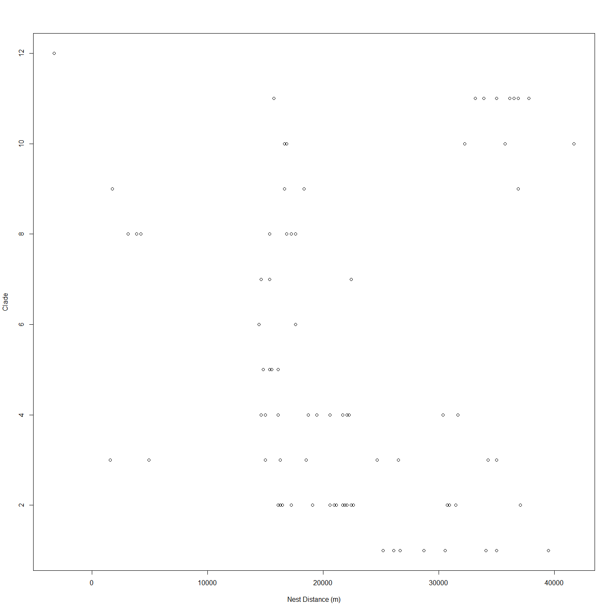

#merged<-merge(Haplogroups,geodist1000, by="row.names")   
#plot(merged$larv.nest,merged$Haplogroups)

This suggests that all haplogroups except 5 exist below some barrier but that only haplogroups 7,4 and 2 also exist above this barrier. On possible explanation that might be inferred from this is that adults migrating upstream for spawning are prevented from doing so by a barrier at 25000m mark but that larvae produced above the barrier are able to disperse and so are represented downstream. The big gap in apparent nests from 6000m to 14000m corresponds with the Tharwa sand slug - a long stretch of sand that has previously been the subject of remedial work because it has been believed to be a barrier to cod migration (ref).

## Code Chunks in this Document

## [1] "Project_Template_and_Knitr" "Set_Global_Options" "LoadLibraries"   
## [4] "Additional_Calculations" "All_Maccullochella_Larvae" "Addicted_2_R_All"   
## [7] "Murray_Cod_Larvae_Only" "A2R_Dendrogram" "Another_Dendrogram"   
## [10] "ExtractClades" "Trout_Cod_Dendrograms" "unnamed-chunk-1"   
## [13] "IteratedMantelGo" "Distance_Matrices_and_Ordering" "Plots_and_Correlation"   
## [16] "Liner_Regression_Model_for_Genetics_and_Distance" "Mantel_Test" "Haplogroups_and_Location"   
## [19] "Include_Labels_for_all_code_Chunks" "IM"